ICPRA E-Newsletter - Issue No. 2 February 2025

Future Events:



**2025 FOP Labor Summit & Legal Counsel Seminar**

**11-14 February 2025**

**Las Vegas, Nevada**

**2025 FOP Wellness Summit & Wellness Professionals’ Forum**

**16-18 February 2025**

**Nashville, Tennessee**

**PFNI Conference**

**20-21 May 2025**

**Enniskillen,**

**Northern Ireland**

In this issue

**President’s Welcome.**

Tom Stamatakis, President, ICPRA | President, Canadian Police Association

**Pay, assaults and reduced terrorist threat level.**

Liam Kelly, Chair | Police Federation for Northern Ireland

**Police Recruiting starts and ends with police retention.**

Patrick Yoes, National President | Fraternal Order of Police

**SAPU Appreciates efforts made by Police on fighting crime.**

Press Release issued by South African Policing Union

**Feedback on Government Employee Housing Scheme.**

South African Police Union

**Joint message highlights vehicle ramming incidents and officer injuries**

Liam Kelly, Chair | Police Federation for Northern Ireland

**Northern Ireland Policing Plan 2025 – 30**

Submission in respect of the Northern Ireland Policing Plan 2025 – 30

**DCI Caldwell presented with KPM by Princess Royal before retirement.**

Liam Kelly, Chair | Police Federation for Northern Ireland

**A Question of numbers**

Liam Kelly, Chair | Police Federation for Northern Ireland

**The Border mess is endangering Police nationwide**

Nate Catura |Special Agent, Social Security Administration

**Wage Negotiations in the Public Service 2025/2026 Financial Years.**

South African Police Union

In this issue cont.

**2025 FOP Labor Summit & Legal Counsel Seminar**

Fraternal Order of Police

**2025 FOP Wellness Summit and Wellness Professionals’ Forum**

Fraternal Order of Police

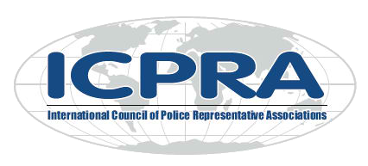

**2025 FOP Labor Summit & Legal Counsel Seminar**

**11-`114 February 2025**

**Las Vegas, Nevada**

**2025 FOP Wellness Summit& Wellness Professionals’ Forum**

**16-18 February 2025**

**Nashville, Tennessee**

**PFNI Conference**

**20-21 May 2025**

**Enniskillen,**

**Northern Ireland**

**President’s Welcome.**

Tom Stamatakis, President, ICPRA – President, Canadian Police Association

**Pay, assaults and reduced terrorist threat level.**

Liam Kelly, Chair – Police Federation for Northern Ireland

**Police Recruiting starts and ends with Police retention.**

Patrick Yoes, National President – Fraternal Order of Police

**SAPU Appreciates efforts made by Police on fighting crime.**

Press Release issued by South African Policing Union

**Feedback on Government Employee Housing Scheme.**

South African Police Union

**Joint message highlights vehicle ramming incidents and officer injuries.**

Liam Kelly, Chair – Police Federation of Northern Ireland

**Northern Ireland Policing Plan 2025 – 30.**

Submission in respect of the Northern Ireland Policing Plan 2025-30

**DCI Caldwell presented with KPM by Princess Royal before retirement.**

Liam Kelly, Chair – Police Federation for Northern Ireland

**A Question of Numbers.**

Liam Kelly, Chair – Police Federation for Northern Ireland

**The Border mess is endangering Police nationwide.**

Nate Catura, Special Agent – Social Security Administration

**Wage Negotiations in the Public Service 2025/2026 Financial Years.**

South African Police Union

**Two Pot System Signed Into Law and Implemented.**

South African Police Union

**Hell For Leather.**

New Zealand Police Union

**2025 FOP Labor Summit & Legal Counsel Seminar.**

Fraternal Order of Police Fraternal Order of Police

**2025 FOP Wellness Summit & Wellne 2025 FOP Wellness Professionals’ Forum.**

Fraternal Order of Police

**No Pay, No Work!**

**South** South African Police Union

**Legally Speaking.**

South African Police Union

**PFNI Conference.**

**Lefgally Speaking** Police Federation Northern Ireland.

Sout

**ICPRA President’s Message**

Tom Stamatakis

As we embark on another year, I want to extend a belated but heartfelt Happy New Year to all of you. I trust that the holiday season provided an opportunity for rest, reflection, and connection with loved ones. Now, as we step into 2025, our shared mission of supporting and strengthening police associations worldwide continues to demand our collective dedication and resolve.

Policing, as we all know, is at the forefront of society's most pressing challenges. The past year has underscored the complex and evolving nature of our work. From managing large-scale protests stemming from the ongoing conflict in the Middle East to addressing demonstrations and unrest fueled by domestic economic challenges, police services worldwide have been called upon to maintain peace, protect communities, and uphold democratic values under incredibly difficult circumstances. These challenges remind us of the crucial role police associations play in advocating for the resources, training, and policies needed to ensure officers can perform their duties effectively and safely.

As a Canadian, I bring to this role a perspective shaped by the unique challenges and priorities facing law enforcement in my home country—many of which resonate with our international members. Recruitment and retention remain pressing issues for police services in Canada and beyond. The demands of modern policing, coupled with heightened scrutiny and changing societal expectations, have made it increasingly difficult to attract and retain qualified officers. Addressing this issue requires innovative strategies, including enhanced support for mental health, competitive compensation, and efforts to maintain and enhance trust with the communities we serve. These are conversations we must continue to prioritize within ICPRA and among our member associations.

The importance of fostering in-person connections was evident during the last ICPRA meeting held in Portugal. This gathering reinforced the value of direct engagement and collaboration, leading to the participation of guests from a number of international associations at our last Canadian Police Association biennial meeting. In speaking with my own members, I can attest that their presence enriched our discussions and provided invaluable perspectives, highlighting the strength and benefits of our global network.

I also want to acknowledge the tireless efforts of police officers who have faced extraordinary pressures over the past year. From responding to natural disasters and public health crises to managing the complexities of cybercrime and international security threats, our members’ work exemplifies resilience and adaptability. Police associations have been instrumental in ensuring officers receive the support they need, whether through advocating for improved working conditions, providing legal assistance, or offering peer support programs. These initiatives underscore the importance of solidarity and collective action, which are at the heart of ICPRA's mission.

The articles featured in this newsletter reflect the diversity and depth of experiences among our member associations. They highlight innovative approaches to common challenges, share success stories, and provide insights that can inspire us all. I encourage you to read these contributions with an open mind and a view to how we can learn from one another to advance our shared goals.

As we move forward into 2025, let us remain committed to fostering collaboration and sharing best practices across borders. Together, we can strengthen our associations and support the dedicated civilian and sworn men and women who serve on the front lines. I also urge each of you to remain steadfast in advocating for the resources, respect, and recognition that our officers deserve. This is a responsibility we owe not only to our members but also to the communities they protect.

In closing, I extend my gratitude to each of you for your continued engagement and contributions to ICPRA. Let us approach this year with renewed determination and a shared vision for a safer, more just global community. On behalf of the ICPRA Executive Committee, I wish you a safe and successful 2025. May this year bring progress, resilience, and strength to all our member associations and the people you represent?

Sincerely

Tom Stamatakis

President, ICPRA

**PAY, ASSAULTS AND REDUCED TERRORIST THREAT LEVEL**

Liam Kelly, Chair | Police Federation for Northern Ireland

We have a situation in Northern Ireland where the terrorist threat level has dropped down, but assaults on officers are on the rise. Add to that a decline in officer numbers and no pay award, and the picture that emerges is not a very happy one.

*To read the full article* [*click here.*](https://pfa.org.au/wp-content/uploads/2024/03/Pay-assaults-and-reduced-terrorist-threat-level.pdf)

**POLICE RECRUITING STARTS AND ENDS WITH POLICE RETENTION**

Patrick Yoes, National President | Fraternal Order of Police

While the ICPRA member associations may be separated by vast oceans, we share similar challenges, recruiting the next generation of law enforcement is a universal challenge.

*To read the full article* [*click here*](https://pfa.org.au/wp-content/uploads/2025/01/Police-Recruiting-starts-and-ends-with-police-retention-ICPRA-Article-6-24.pdf)

**SAPU APPRECIATES EFFORTS MADE BY POLICE ON FIGHTING CRIME**

Press Release issued by South African Policing Union

The South African Policing Union (SAPU) appreciates efforts made by police in fighting crime

as we have seen the crime statistics released by the Minister of Police Senzo Mchunu today

Monday 25th November 2024.

*To read the full article* [*click here*](https://pfa.org.au/wp-content/uploads/2025/01/SAPU-APPRECIATES-EFFORTS-MADE-BY-POLICE-ON-FIGHTING-CRIME.pdf)

**FEEDBACK ON GOVERNMENT EMPLOYEE HOUSING SCHEME**

South African Police Union

The issue of descent housing for public servants is and has always been a very sensitive issue since majority of public servants cannot afford to own descent housing clearly because they are not affordable for them to buy because of low salaries.

*To read the full article* [*click here*](https://pfa.org.au/wp-content/uploads/2025/01/Government-Housing.pdf)

**JOINT MESSAGE HIGHLIGHTS VEHICLE RAMMING INCIDENTS AND OFFICER INJURIES**

Liam Kelly | Police Federation for Northern Ireland

The Police Federation for Northern Ireland has said that using a vehicle as a weapon is a clear intention to cause serious injury or even kill police officers.

*To read the full article* [*click here*](https://pfa.org.au/wp-content/uploads/2025/01/PFNI_VEHICLE-RAMMING.pdf)

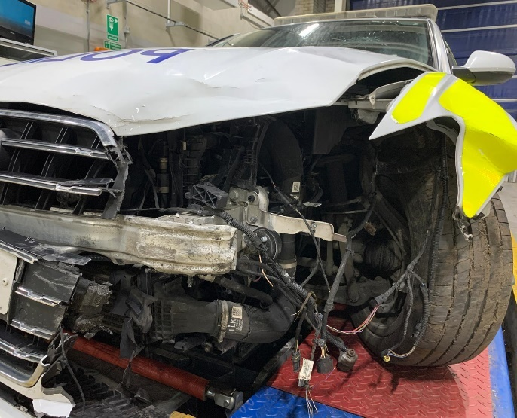 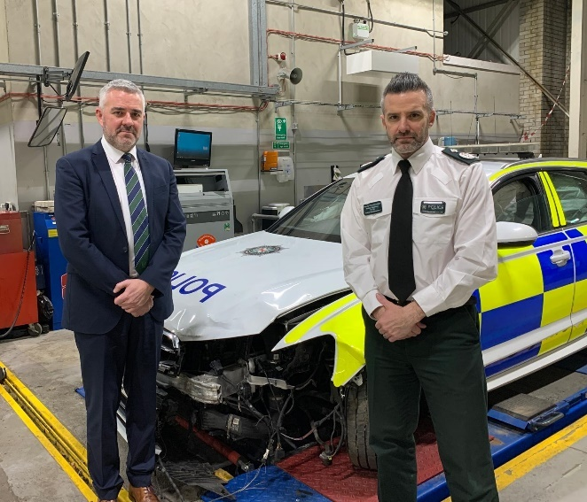- - Damaged police car Liam Kelly & Chief Constable Singleton

**NORTHERN IRELAND POLICING PLAN 2025 – 30**

Submission in respect of the Northern Ireland Policing Plan 2025 – 30

The Police Federation for Northern Ireland welcomes that this Consultation will determine the range and shape of policing services up to 2030. This organisation is a policing advocate and wants what is best for the Service, our officers and the public they serve.

*To read the full submission* [*click here*](https://pfa.org.au/wp-content/uploads/2025/01/NIPB_PolicingPlanConsultationResponse.pdf)

**DCI CALDWELL PRESENTED WITH KPM BY PRINCESS ROYAL BEFORE RETIREMENT**

Liam Kelly | Police Federation for Northern Ireland

DCI John Caldwell, accompanied by wife Jacquelineand son Jack, travelled to Buckingham Palace to be presented with the KPM by the Princess Royal.

December was a watershed moment for John and his family. A week on from the ceremony in London, John was medically discharged from the PSNI to begin a new chapter in his life.

John was shot nine times in a car park at Omagh Leisure centre in February 2023. The cowardly attack on the off-duty officer by a dissident republican gunman was widely condemned by all political parties and all right-thinking people in our society.

*To read the full article* [*click here*](https://pfa.org.au/wp-content/uploads/2025/01/DCI-Caldwell_KPM.pdf)

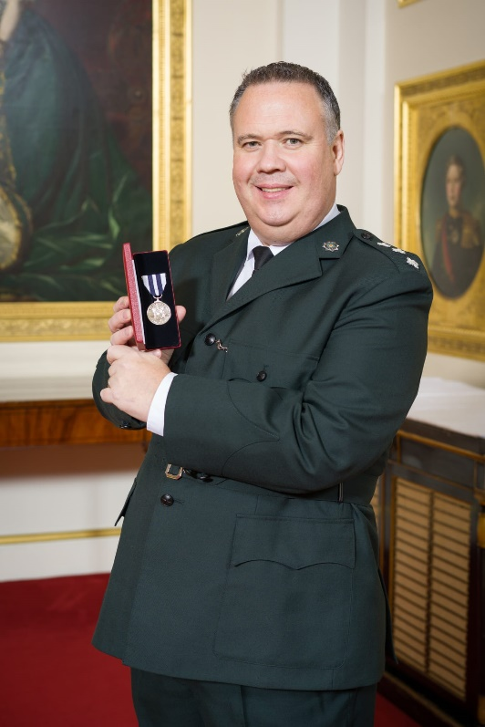 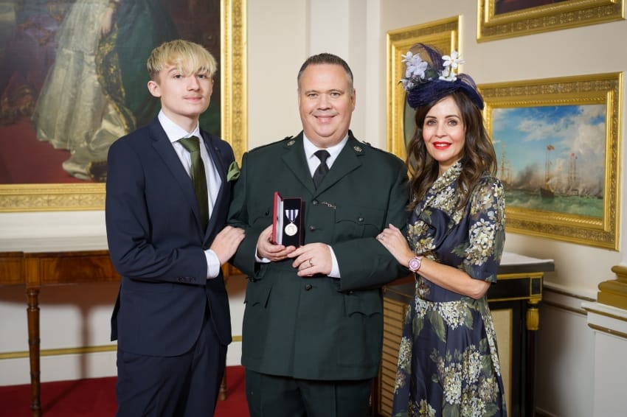

Detective Chief Inspector John Caldwell DCI John Caldwell with his wife Jacqueline & son Jack.

**A QUESTION OF NUMBERS**

Liam Kelly | Police Federation for Northern Ireland

There has been a lot of talk about policing plans covering the short-to-medium term. There is the PSNI’s Workforce Recovery Plan, the Northern Ireland Policing Board Plan to take us up to 2030 and on top of that, we have the less than impressive draft Programme for Government. A draft Stormont Budget prepared by the Department of Finance will now outline the resources to be allocated to all Departments. Justice will get its headline figure out of which that Department will determine what the PSNI receives in the next financial year.

*To read the full article* [*click here*](https://pfa.org.au/wp-content/uploads/2025/01/Numbers.pdf)

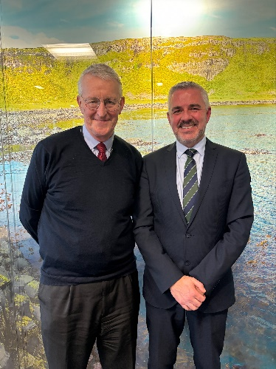 Liam Kelly & Secretary of State Hilary Benn MP

**THE BORDER MESS IS ENDANGERING POLICE NATIONWIDE**

Nate Catura | Special Agent, Social Security Administration – Officer of Inspector General

In March, Border Patrol Chief Jason Owens announced that there had been 140,000 known “got-aways” at the Southwest border since Oct. 1, 2023. Known got-aways refers to the number of migrants that were able to evade capture while crossing the border illegally into the United States.

*To read the full article* [*click here*](https://pfa.org.au/wp-content/uploads/2025/01/Guest-Editorial_-The-Border-Mess-is-Endangering-Police-Nationwide-_-Police-Magazine.pdf)

**WAGE NEGOTIATIONS IN THE PUBLIC SERVICE 2025/26 FINANCIAL YEARS**

South African Police Union

The round of wage negotiations has since ensued in the **PSCBC for the financial years 2025/2026** after the last leg of the 2023 agreement has been implemented necessitating for parties to go back to the negotiation table. At SAPU we made it a point to make sure that we align with our **SAPU Business plan goal 4 which speaks to Building an Effective Trade Union on collective bargaining and goal 1** under Improve the Quality and Success Rate on Research, where both goals direct to conducting a research before entering into wage negotiations. The research we conducted was based on the following indicators: **Effects of Collective Wage Agreements, Impacts of Non-Implementation, Effects of Bloated Wage Bill, Effects of Economic Uncertainly and Practical Effects of Proposals.**

*To read the full article* [*click here*](https://pfa.org.au/wp-content/uploads/2025/01/Wage-negotiations.pdf)

**TWO POT SYSTEM SIGNED INTO LAW AND IMPLEMENTED**

South African Police Union

The issue of the Two Pot system has since been introduced to the PSCBC during consultation where Government Employees Pension Fund (GEPF) came to unpack the new system and to take labour into confidence way before it being signed into law.

*To read the full article* [*click here*](https://pfa.org.au/wp-content/uploads/2025/01/Two-pot-system.png.pdf)

HELL FOR LEATHER

New Zealand Police Association

By the end of this month, gang patches will have been legislated out of the New Zealand public arena and Police argue no gang member can pretend to be unaware of that fact.

*To read the full article* [*click here*](https://pfa.org.au/wp-content/uploads/2025/01/HELL-FOR-LEATHER.pdf)

**2025 FOP LABOR SUMMIT & LEGAL COUNSEL SEMINAR**

Patrick Yoes, National President | Fraternal Order of Police

The Fraternal Order of Police is proud to invite ICPRA member organizations and police labor professionals to the 2025 FOP Labor Summit and Legal Counsel Seminar, taking place February 11-14, 2025, in vibrant Las Vegas, NV.

Both events feature two days of intensive training on the latest trends in police labor and legal representation of police officers.

**Labor Summit: February 11-12** Topics include:

* Recent developments in Public Safety Labor Issues
* Improving the Future of Policing
* The future of policing through Artificial Intelligence
* Use of AI in policing
* Controversial Issues in Policing

For more information, visit: <https://national.fop.net/labor-2025>

**Legal Seminar: February 13-14** Topics include:

* Insight from a City Attorney’s Perspective
* Defending Law Enforcement Officers
* Status of Citizens Review Boards
* Representing Law Enforcement Officers in Civil and Criminal Cases
* Just Cause Standards
* Use of AI in Legal Documents and Proceedings

For more information, visit: <https://national.fop.net/legal-2025>

**2025 FOP WELLNESS SUMMIT & WELLNESS PROFESSIONALS’ FORUM**

Patrick Yoes, National President | Fraternal Order of Police

Join Us for the 2025 FOP Wellness Summit and Wellness Professionals’ Forum in Nashville, TN

The Fraternal Order of Police is proud to invite ICPRA members organizations and wellness professionals to the 2025 Wellness Summit and Wellness Professionals’ Forum, taking place February 16–18, 2025, in vibrant Nashville, Tennessee.

The National Fraternal Order of Police is deeply committed to improving the lives and wellness of law enforcement officers and their families. Realizing that wellness is holistic, the NFOP Division of Officer Wellness has assembled a top-tier event featuring an interactive format and expanded course offerings on various topics in wellness for police officers, their families, and clinicians serving law enforcement clients.

Features:

* Over 20 different presentations on current wellness topics featuring nationally renowned speakers.
* Expert panel discussions on topics most current in law enforcement wellness.
* Opportunities to participate in hands-on wellness activities.
* A variety of training sessions which will ensure participants carry away a wealth of wellness tools.
* Opportunities to learn more about FOP Vetted & Approved Wellness Programs and Providers.
* The Blue Family Networking Room is a space where family members who travel with attendees can gather to meet and fellowship with other law enforcement families.

For more information, visit: <https://simplebooklet.com/dashboard.php?redirect_url=%2Fdashboard.php>

**NO PAY, NO WORK!**

Div Odendaal | South African Police Union

We are all familiar with the principle of **NO WORK, NO PAY** which is applied in the context of striking employees. In this article we want to share with you the converse: **NO PAY, NO WORK.**

*To read the full article* [*click here*](https://pfa.org.au/wp-content/uploads/2025/01/No-Pay-No-Work.pdf)

**LEGALLY SPEAKING**

South African Police Union

As overtime duties must be pre-authorised, no employee can be forced to perform overtime duties **without authorization having been obtained.**

*To read the full article* [*click here*](https://pfa.org.au/wp-content/uploads/2025/01/Legally-Speaking.pdf)

PFNI CONFERENCE

The PFNI conference will be held on Tuesday 20 and Wednesday 21st May at the Killyhevlin Hotel, Enniskillen, Northern Ireland. Should any of the ICPRA Executive wish to attend they should contact Liam Kelly directly at [chairman@policefedni.com](mailto:chairman@policefedni.com) for a formal invitation.

The End